 Introduction to Robotics

Group 13

Week 05 Date 20/02/15

Fergal Lonergan, Ruairí O’Donoghue, Kevin O’Flannagáin

Assignment: 2 [Obstacle Course Challenge](https://csimoodle.ucd.ie/moodle/mod/resource/view.php?id=27616)

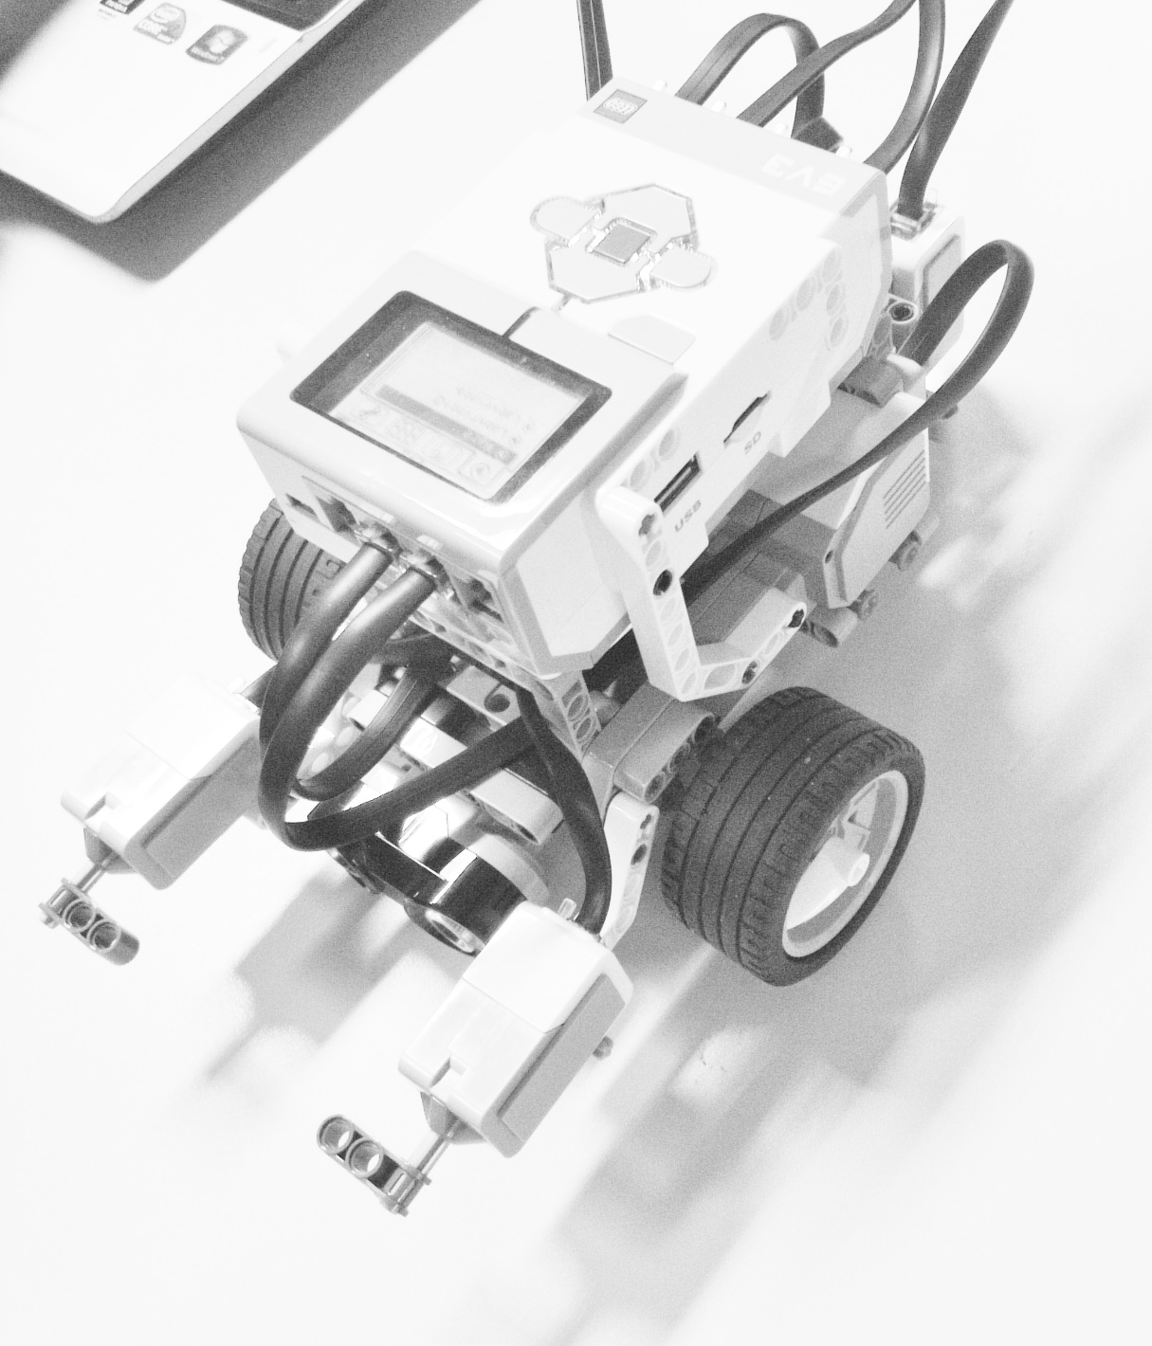 Picture of robot used for [Obstacle Course Challenge](https://csimoodle.ucd.ie/moodle/mod/resource/view.php?id=27616)

Goal: Our goal for this challenge was to design a robot and then write a program to get our robot through the ‘[Obstacle Course Challenge](https://csimoodle.ucd.ie/moodle/mod/resource/view.php?id=27616)’. The robot needed to navigate the ‘Obstacle Course’ using the sensors we chose to add to our robot without touching any cones or boxes. It also had to determine a touch from one of the boxes, follow a red line and then find the calibration zone without touching any obstacle, for this we used the sonar sensor. We also decided to eliminate as much dead reckoning as possible in our program and utilise the sensors to their full extent.

Robot design: We decided to add two collision sensors, the colour sensor and the sonar sensor to the robot.   
The colour sensor was placed along the centre line of the chassis of the robot at the back in order to speed up the line following section as the turns could be reduced. It also ensured that the robot had a good level of clearance between the obstacles.   
We chose two collision sensors, on the front of our robot, to increase reliability of the touch on the box, and our sonar sensor was placed in the centre of the front to read an accurate distance from obstacles.

Programs: Before the lab we experimented separately with the robot in the virtual world. We wrote a basic program each before coming to the lab and then compared programs before deciding on the final program to use. We decided to complete each obstacle of the course separately before moving on to the next.   
Firstly, we tackled the touch off the box and we completed this task quite quickly after calibrating our turns after the collision.  
We then moved onto our line following section of the program which took significantly more work. Firstly due to the fact that the colour sensor would not work if the battery was too low, secondly, we needed to judge the optimum motor speeds for our drives and turns when navigating along the line. At the end of the line, as our colour sensor was on the back of our robot and our sonar and collision sensors were on the front, we did a 180° turn until we found the line again.  
We then used our sonar sensor to navigate its way into the calibration zone and park there.

Learned: We learned that in the virtual world the robot works more fluidly than the physical robot. We also noted that some of the sensors, mainly the sonar sensor and motor sensors, take some calibration before the robot does exactly as you want it to. Furthermore we found that there is a balance to be made when trying to achieve the fastest time and that a motor output of 100% does not necessarily return the fastest lap time. Another point of note was that the dual colour/light reflection sensor alternates its function every time a program is run, regardless of the code inputted.

Finished Code: In the end we simplified our code using a series of functions in our main program and also allowed for any slight calibrations that had to be made to sensors as well as manipulating motor speeds to achieve the fastest possible outcome. The code is commented clearly with the functions and main program explained in a step by step manner.

Work Distribution: We distributed the workload evenly in the challenge. We all collaborated on the code and each picked a different part of this journal, according to who spent the most time, and was most familiar to, each section of the challenge.